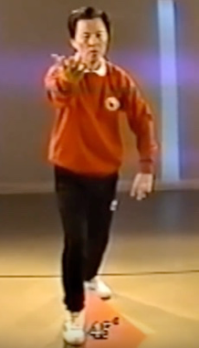**1: The 45°angle step.**

In any typical full-step in the set, the front foot points straight ahead and the back foot points 45 relative to the front foot. Also, in the correct posture, if you slide the front foot straight back it does not touch the back foot. In other words, the left and right heels are on either side of an imaginary line.

**2. Positioning the front knee:**

The front leg from knee to ankle should be perpendicular to the ground when in the forward position. In other words, the front knee should be above and not beyond the middle of the front foot. If the knee is too far forward undue pressure is placed on the knee joint

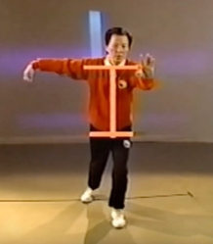**3. Squaring the hips**.

As the weight shifts forward in any typical full step movement, the shoulders and hips should turn to face the direction that the front foot is pointing

**4. Straight line from head to heel.**

In the forward position of a typical full-step movement the back is positioned in such a way that there is a straight line from the head to the back of the heel. In this way the back is neither arched nor bent too far forward.

**5. Equal & Opposite Forces.**

In all movements a push with one arm should be matched by an equal push with the other arm. In many (but not all) cases these pushes are in opposite directions